5. Code

5.1. Base Classes:
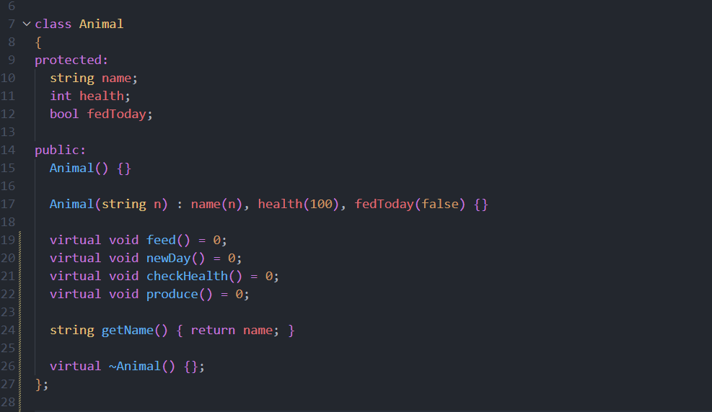

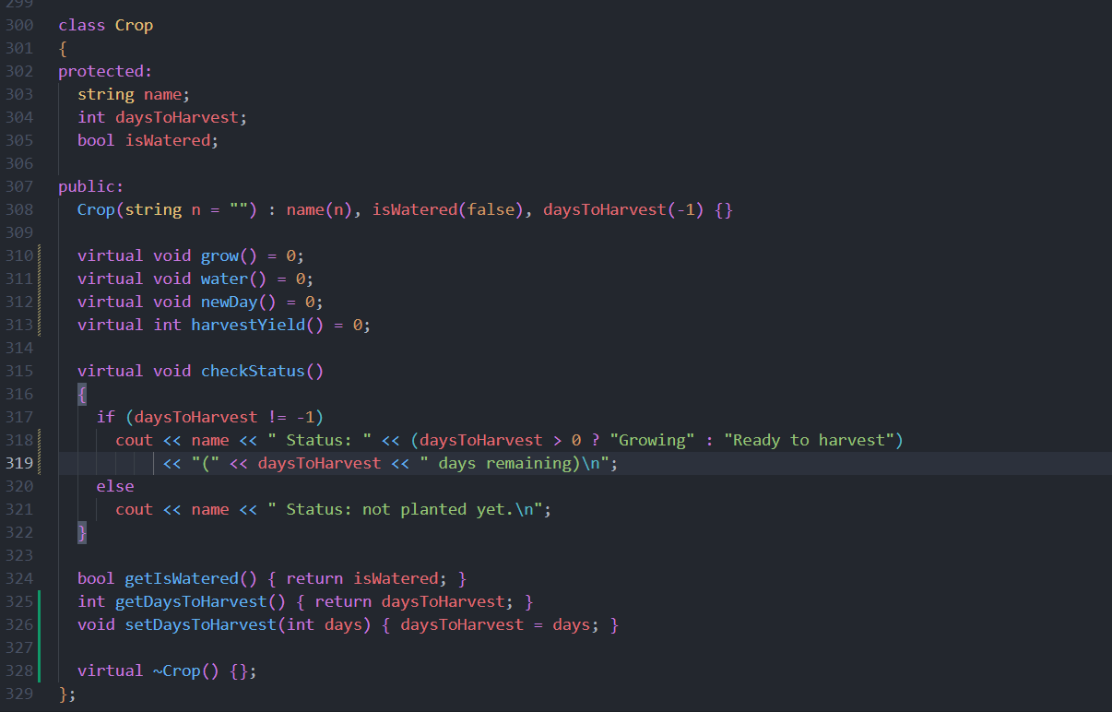

5.2. Derived Classes
First we’ll start with overridden methods of derived classes
Below is the code of Cow child class
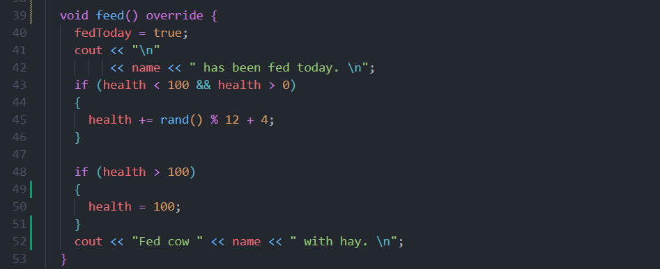

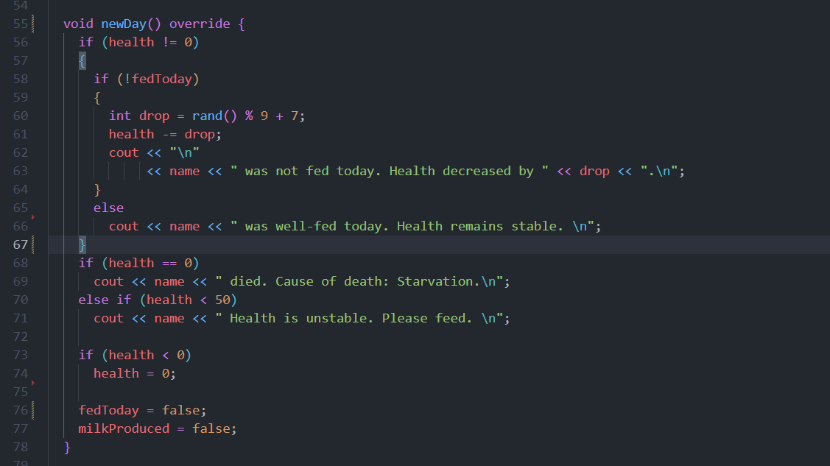

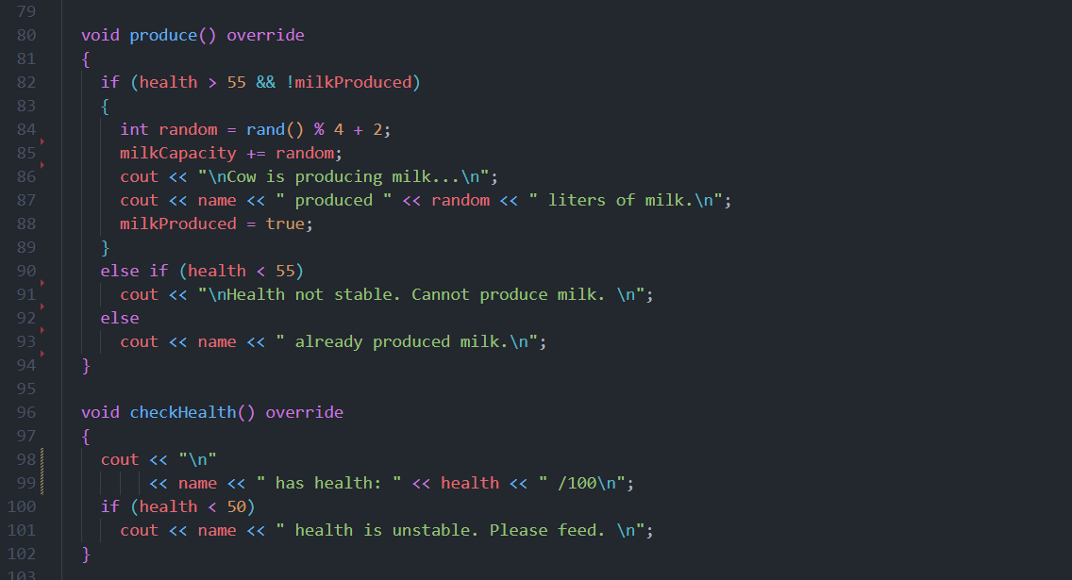

Similarly now the code for the crop derive class
Below is the code of Wheat child class overridden methods

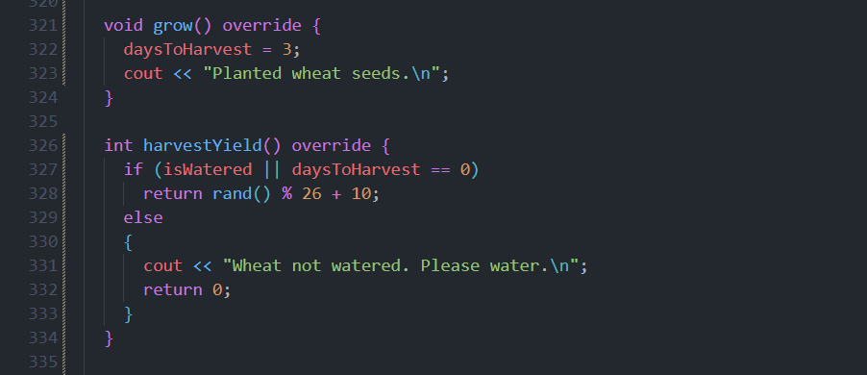

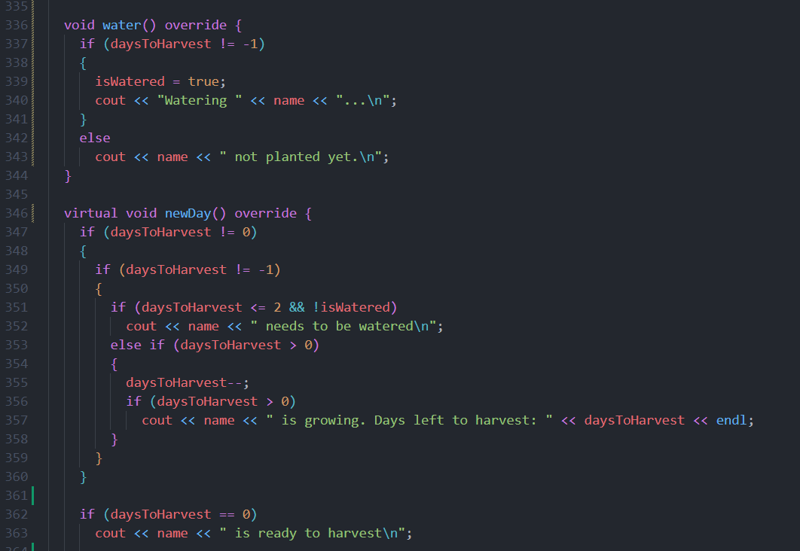

Variables (including static too) and objects

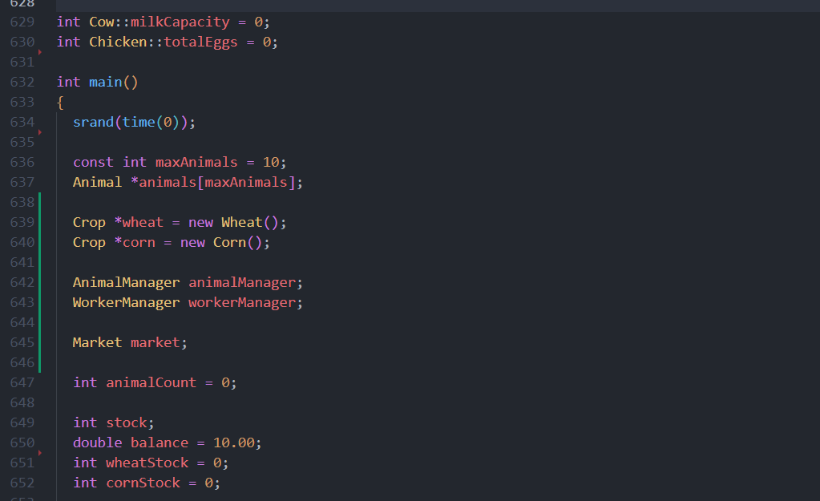

6. Code + Output:

6.1. Day Simulation:

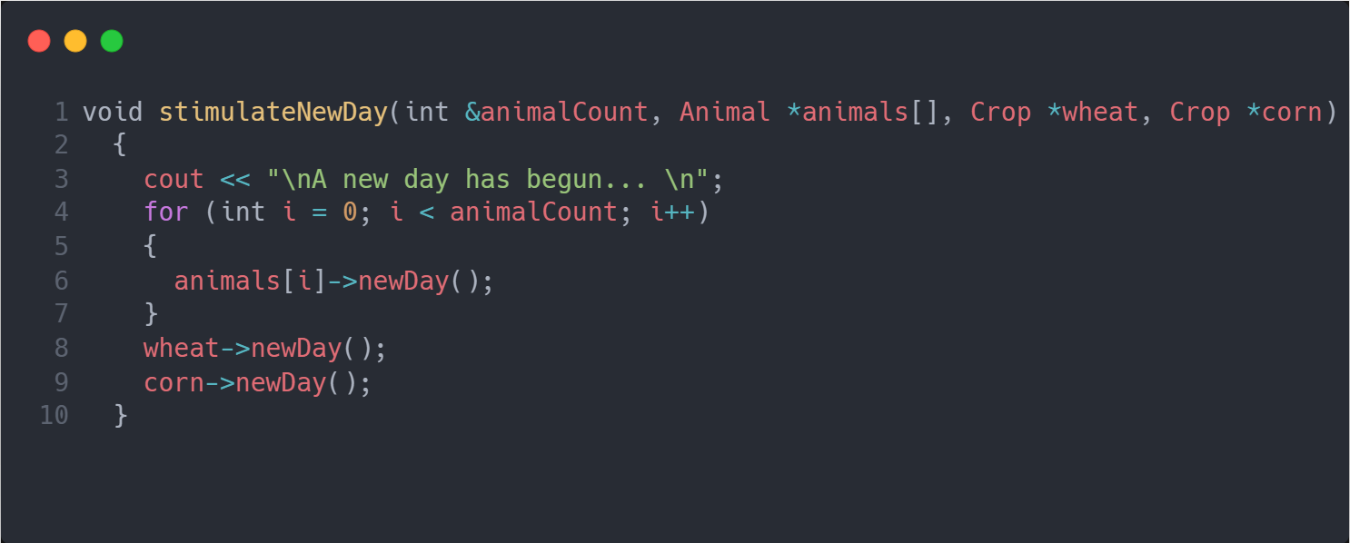

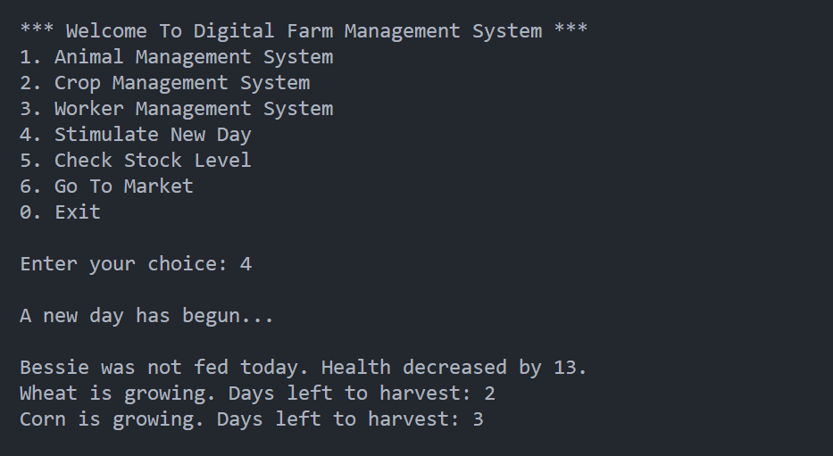

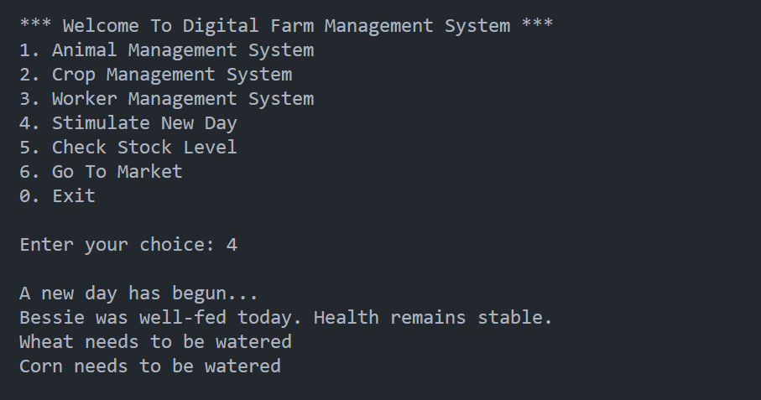

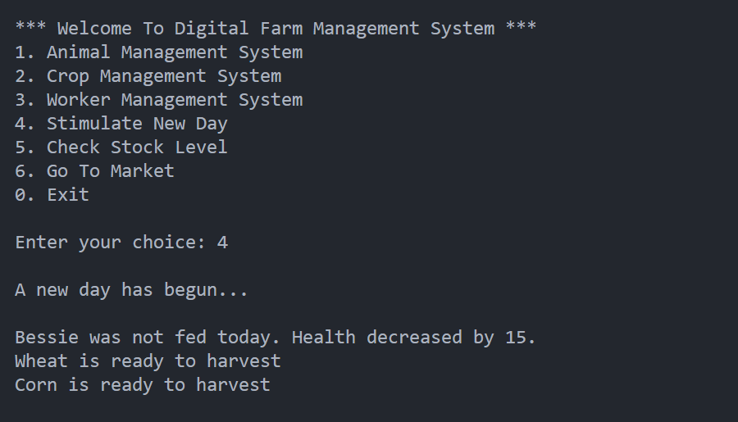

6.2. Market Transactions:
Buying goods
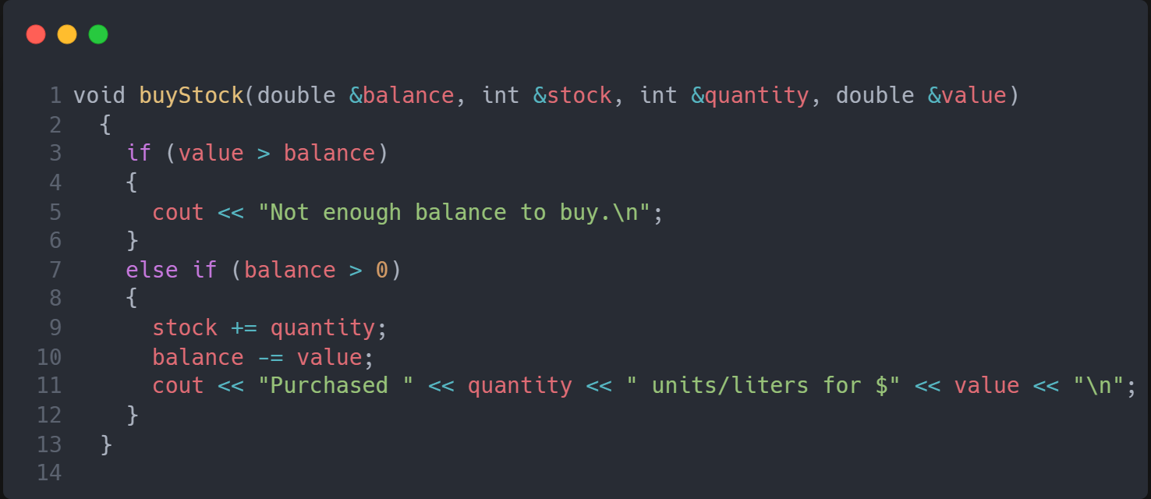
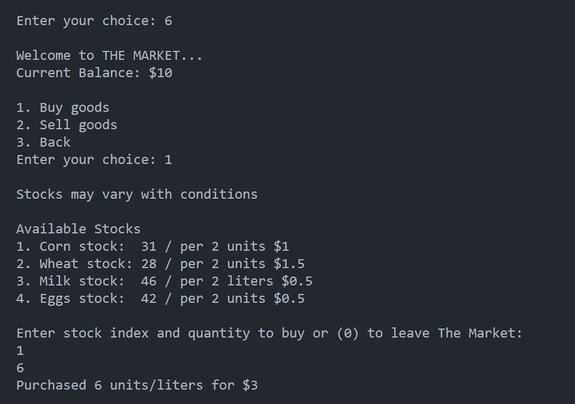

Selling goods
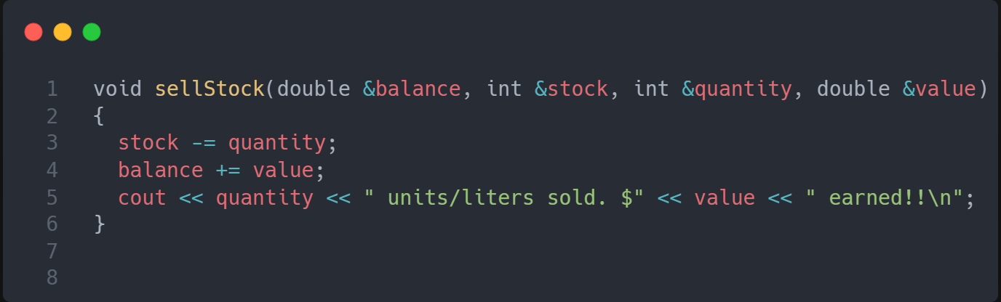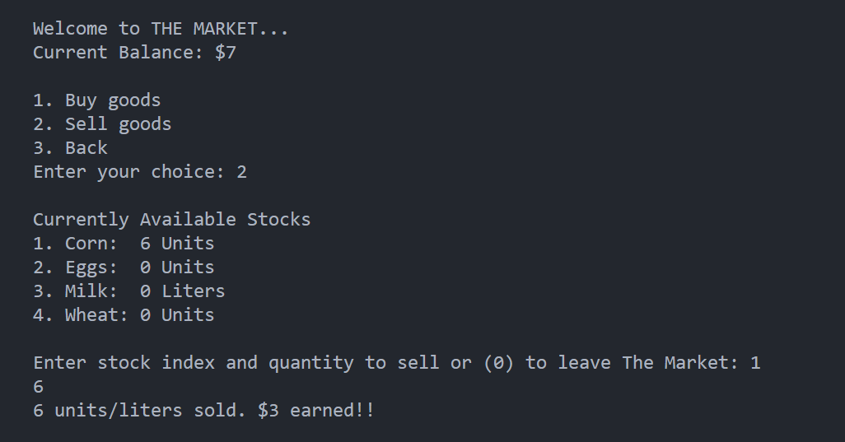

7. Streamlit UI
After building the basic console version of my Digital Farm Management System, I decided to improve the user experience by adding a Graphical User Interface (GUI) using the Streamlit software in C++. The purpose of this was to make the system more interactive, beginner-friendly, and closer to how real applications work visually.

In the GUI version, actions like feeding animals, planting crops, and checking balances are done through buttons, message boxes, and input fields, instead of typing commands in the console. This makes the simulation easier to use and more engaging, especially for users who may not be comfortable with text-based interfaces.

Even though the backend logic of the farm was originally written in C++, using Streamlit helped me present the same concepts in a cleaner, more user-friendly way. This experience taught me how frontend and backend systems can work together, and how Python can be used to quickly build interfaces on top of existing logic.

7.1 Dashboard
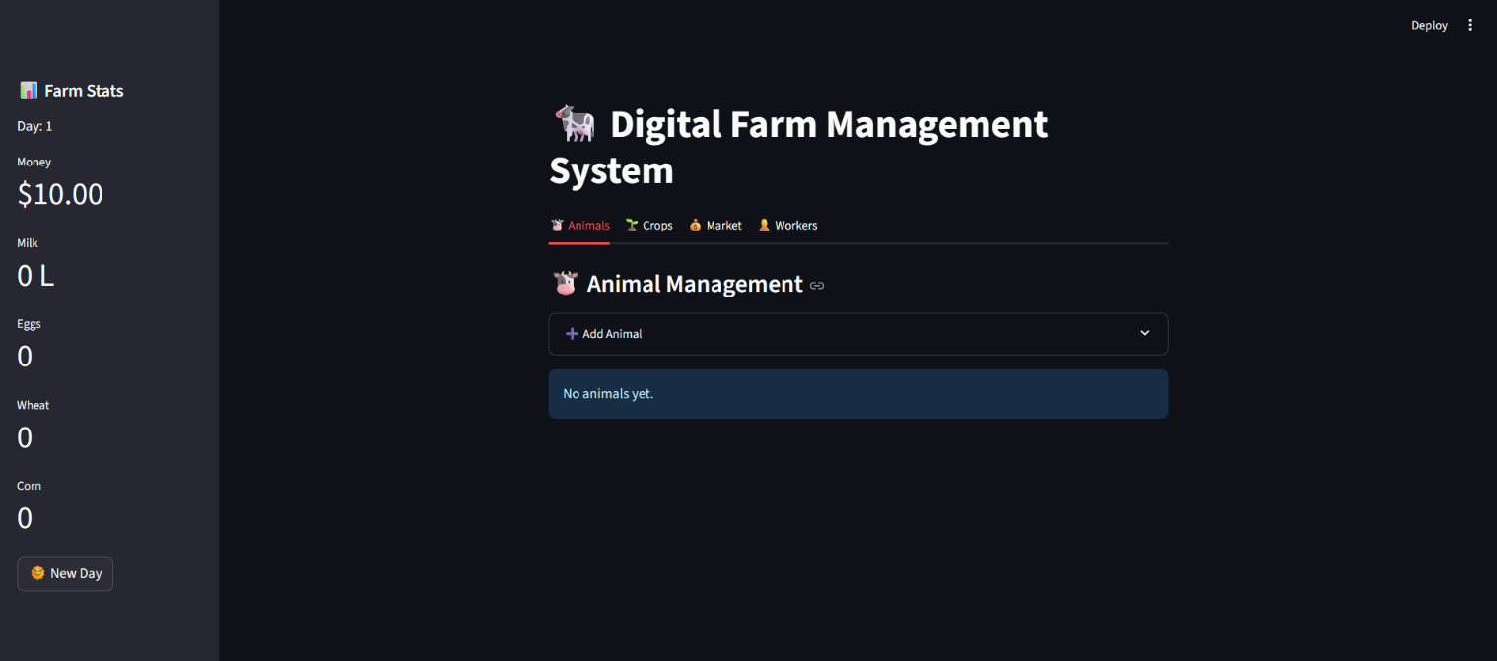

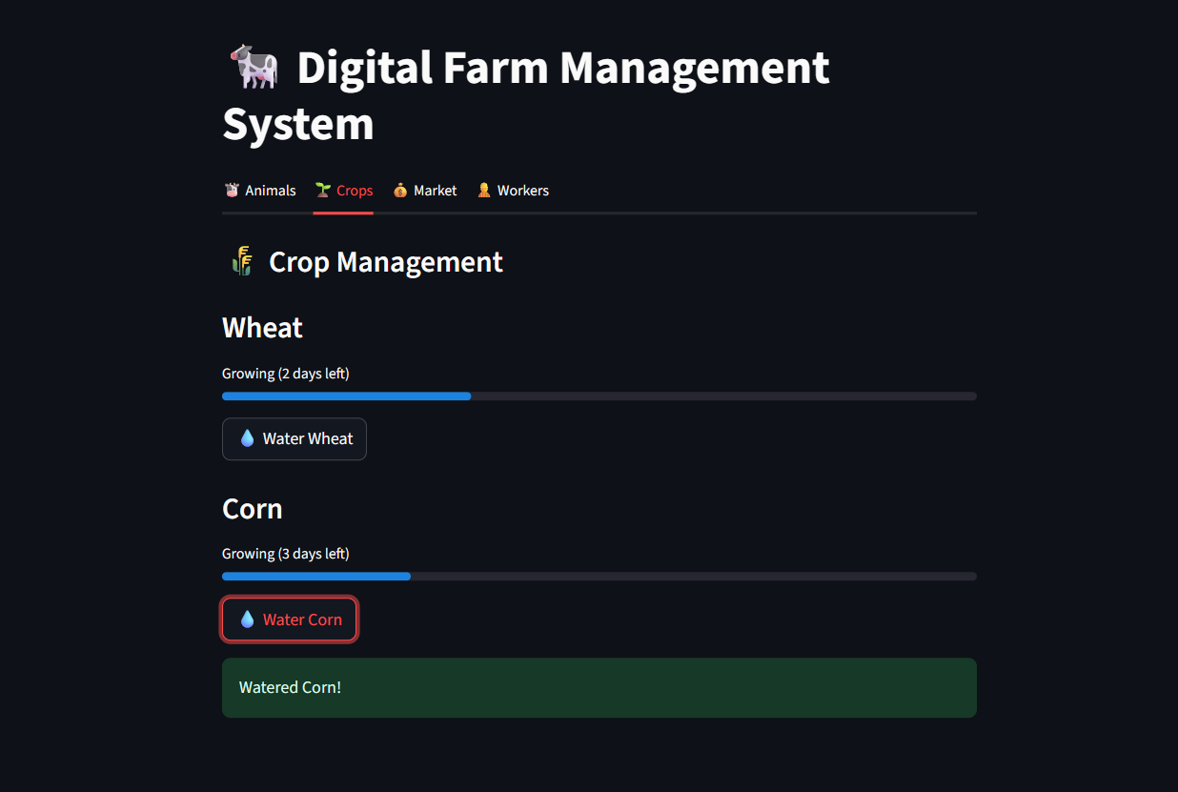

Simulation stats after some days
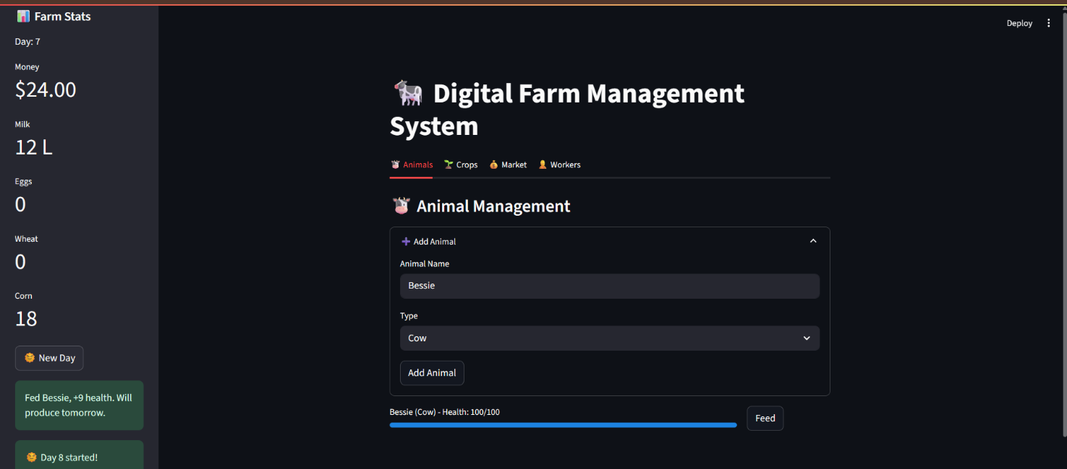

7.2 Market Panel:
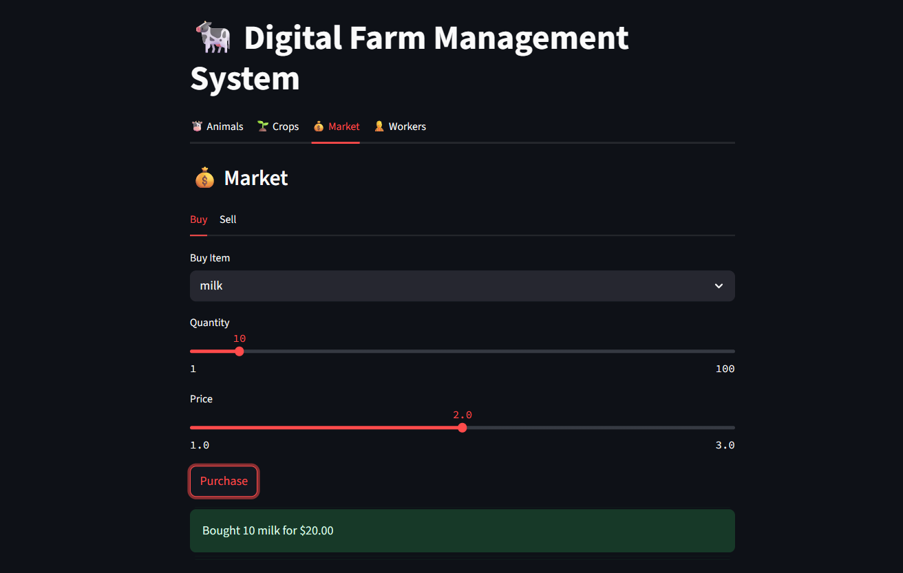

8. Automation Difference Between Console & GUI Versions
In the C++ console version, all tasks like feeding animals, watering crops, and harvesting are done manually by the user. This was done to focus on implementing core logic using basic programming and object-oriented principles.
In the Streamlit GUI version, I introduced optional automation using checkboxes for worker roles:
- Auto Feed Animals
- Auto Water Crops
- Auto Harvest Crops
This simulates real-world farm automation, making the simulation more realistic and user-friendly. It also shows how the same logic can evolve with better user interfaces.

8.1 Command Line Interface:
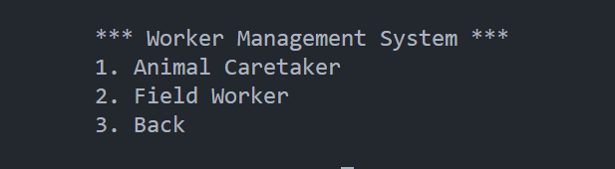
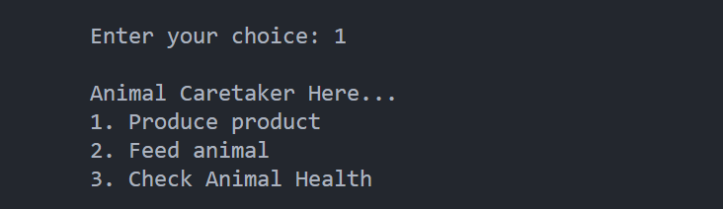
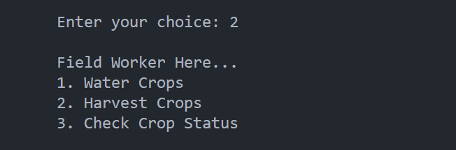

8.2 Graphical User Interface:

